Online Tutoring Session Request

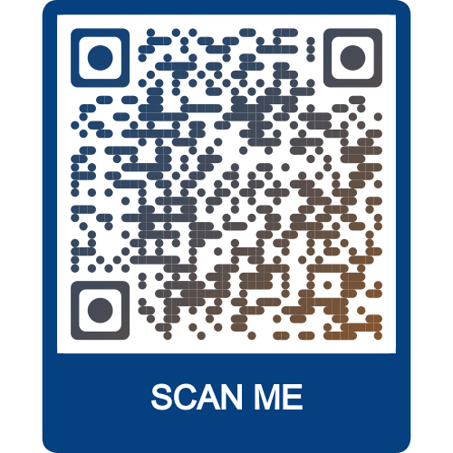

A tutor will email you a link with the meeting information.